

LOW & LEVEL

DOCUMENT

***Restaurant Rating PREDICTION***

***January 23, 2023***

***Written BY SOFANA BENOUTIQ & OTHMANE ZOUBAIRI***

1 | P a g e

**Contents**

**1. Introduction**.............................................................................................1

**1.1.What is Low-Level design document?** .......................................................2

**1.2.Scope**.......................................................................................................3

**2. Architecture**............................................................................................4

**Architecture Description**.......................................................................4

**Data Description**.........................................................................................5

**Dataingestion**……………………………………………………………………...5

**Datavalidation**……………………………………………………………………..6

**Data Transformation**..............................................................................6

**Model Trainer**...............................................................................................7

**Model Evaluation**..........................................................................................7

**Model Pusher**.................................................................................................8

**Deployment**.....................................................................................................9

**Interface**………………………………………………………………………………10

**Test Cases** ....................................................................................................11

**DOCUMENT VERSION CONTROL**

Change Record

|  |  |  |  |
| --- | --- | --- | --- |
| Date Date | Version | Comments | Author |
| 22/12/2022 01/01/2023 | 0.1 0.1 | Introduction and  architecture defined | othmane zoubairi  &  Sofana  Benoutiq |
| 01/01/2023 15/01/2023 | 0.2 0.2 | Architecture updated  Architecture updated  and unit test case  and unit test case  defined  defined | &  Sofana  Benoutiq |

ABSTRACT

The basic idea of analyzing the Zomato dataset is to get a fair idea about the factors affecting the establishment of different types of the restaurant at different places in different Cities, aggregate rating of each restaurant, With each day new restaurants opening the industry hasn't been saturated yet and the demand is increasing day by day.

Inspite of increasing demand it, however, has become difficult for new restaurants to compete with established restaurants.. Most of the people here are dependent mainly on the restaurant food as they don’t have time to cook for themselves.

It is important to know in which cities they are good Restaurant and which not.

**1 Introduction**

**1.1 What is Low-Level design document?**

The goal of LLD or a Low-level design document is to give an  internal logical design of the actual program code for the Credit  Card Default Probability Prediction. LLD describes the class  diagrams with the methods and relations between classes and

the program specs. It describes the modules so that the  programmer can directly code the program from the document.

1.2 Scope

**Low-level design (LLD) is a component level design process  that follows a step-by-step refinement process. This process  can be used for designing data structures, required software  architecture, source code and ultimately, performance  algorithms. Overall, the data organization may be defined during  requirement analysis and then defined during data design work.**

2 Architecture

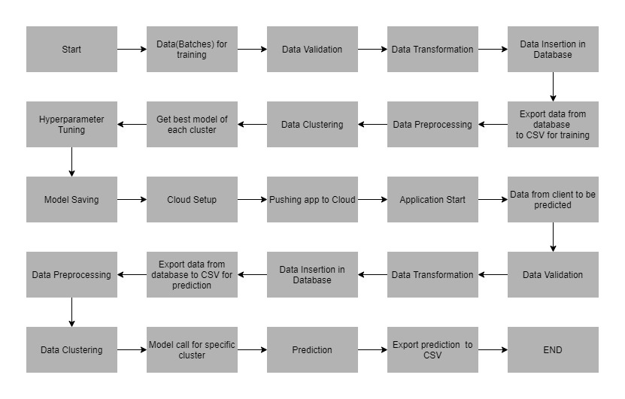

3 Architecture Description 3.1 Data Collection

For training and testing the model, I used the public set  available in Ineuron intership :

URL – https://raw.githubusercontent.com/mrinalmayank7/datascience/main/zom.csv

3.2 Data Dictionary

Customer details:[¶](https://www.kaggle.com/code/dscodingp19/travel-package-purchase-prediction" \l "Customer-details:)

1. Restaurant Id: Unique id of every restaurant across various cities of the world
2. Restaurant Name: Name of the restaurant
3. Country Code: Country in which restaurant is located
4. City: City in which restaurant is located
5. Address: Address of the restaurant
6. Locality: Location in the city
7. Locality Verbose: Detailed description of the locality
8. Longitude: Longitude coordinate of the restaurant’s location
9. Latitude: Latitude coordinate of the restaurant’s location
10. Cuisines: Cuisines offered by the restaurant
11. Average Cost for two: Cost for two people in different currencies (local currency)
12. Currency: Currency of the country
13. Has Table booking: yes/no
14. Has Online delivery: yes/ no
15. Is delivering: yes/ no
16. Switch to order menu: yes/no
17. Price range: range of price of food
18. Aggregate Rating: Average rating out of 5
19. Rating color: depending upon the average rating color
20. Rating text: text on the basis of rating of rating
21. Votes: Number of ratings given

3.3 Variable Information

This is a regression problem. The target variable is Rating . The aim of the project is to predict  the probability of restaurant rating given various attributes of the  customer given below.

4. Data Ingestion

* data in data ingestion folder
* Split data in train and test data
* Saving data in data ingestion folder

4.1 Data Validation

* data in data validation folder
* data drift and EDA
* Report in evidently to show and analysis Data Distribution
* Saving report in data validation Folder

4.2 Data Transformation

* data in data Transformation folder
* Using Pipeline and columns transformer to processing Data
* Splitting data in array by Standard Scalar and different technique
* Putting train array data and test array data in transformation folder and creating prepossessing Object file.
* Saving Processing pkl in data transformation folder for future Transformation
  1. Model Trainer
* We have built various models like Descision Tree Regressor, Gradient Boosting and Linear Regressor, etc. • Each of the above models was built taking their default parameters.
* We have use Gridsearch CV to have best model in comparison all models
* We save best model file in Model Trainer folder

5.1 Data Evaluation

* We used Metric for Regression :
* we save the evaluation model in evaluation Folder
* Reason For Choosing This Model : Random Forest Regressor

**5.2 Model Pusher**

* The best model was Random Forest Regressor using GridSearchCV.
* The model has been saved in ‘Model.pkl’
* If we have an updated better model by new data ,

we can save it in model pusher save models folder

**5.3 Heroku Deployment**

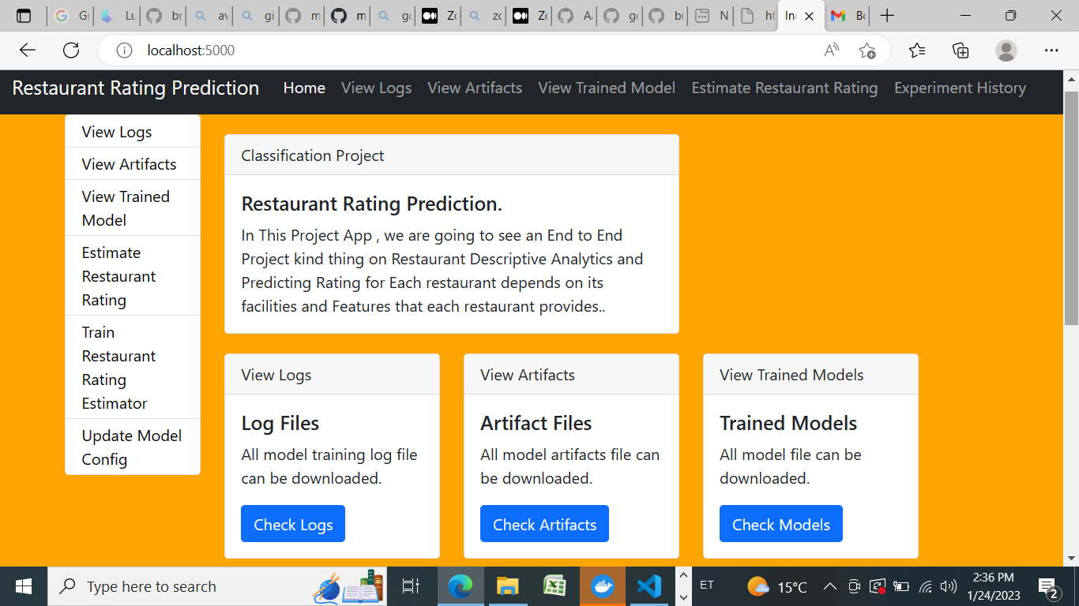

I deployed the application on the web using Heroku

The deployment part of the code runs in the “app.py” file, connecting with the web page designed using HTML with CSS  styles.The html front end template can be found in templates  folder.

*URL - https://- app-rest-rating-predherokuapp.com/

*Deployemnt dosen work in Heroku Free Version if the size data more than 500 MB in free version

1. User Interface



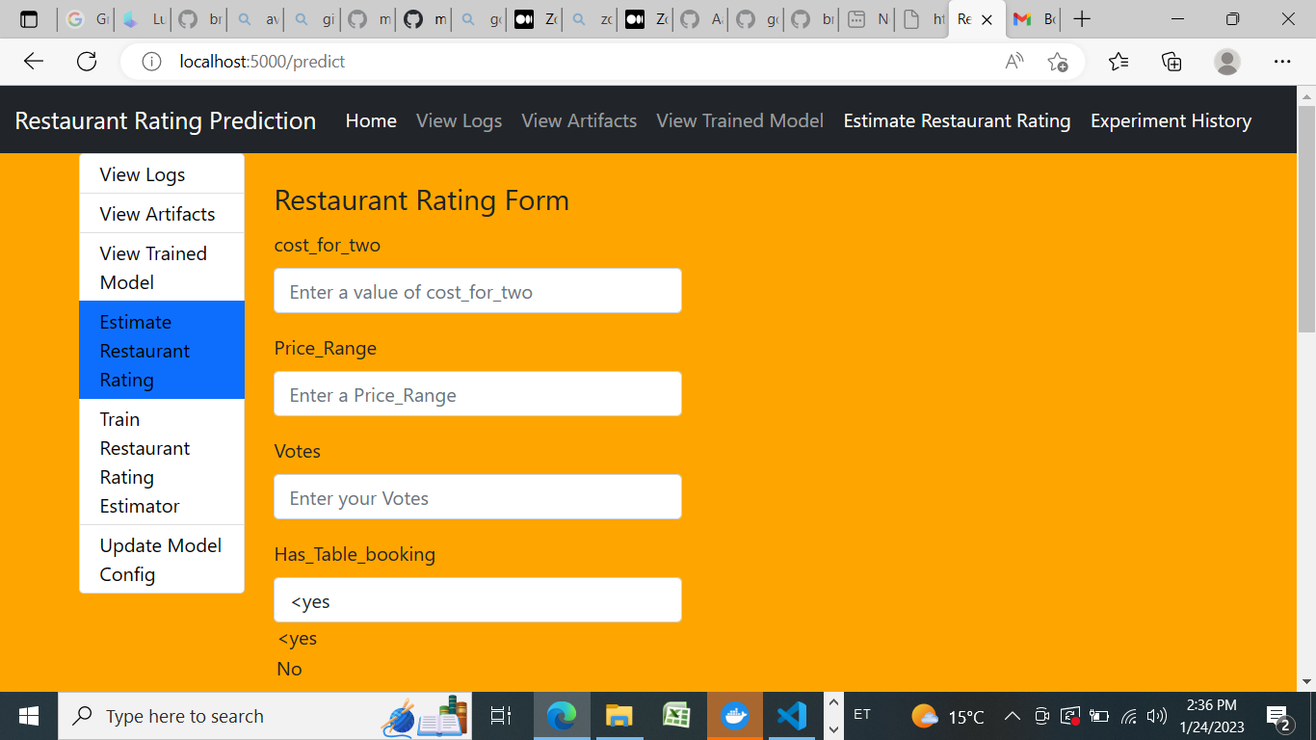

7 Unit Test Cases

|  |  |  |
| --- | --- | --- |
| Test Case Description | Pre-Requisite | Expected-Result |
| Verify whether the  Application URL is  accessible to the user | 1. Application URL  should be defined | Application URL should be accessible to the user. |
| Verify whether the  Application loads completely  for the user when the URL is  accessed. | 1. Application URL is Accessible.  2. Application is  deployed. | The application should load completely for the user  when the URL is accessed. |
| Verify whether user can edit all the input fields | 1. Application URL is Accessible.  2. Application loads completely for the  user.  3. All the input fields Loaded. | User should be able to edit  all the input fields |
| Verify whether user gets “Predict” button to make predictions on the given inputs | 1. Application URL is Accessible.  2. Application loads completely for the  user.  3. All the input fields Loaded. | User should get a “Predict” button to make predictions  on the given inputs. |
| Verify whether user is  Presented with  recommended results on  clicking the “Predict” button | 1. Application URL is Accessible.  2. Application loads completely for the  user.  3. All the input fields Loaded. | Users should be presented with recommended results  on clicking the “Predict”  button. |